Intersecting Lines in Solid Geometry

Definition
# Source: AI Source: Provided by: [Data Path: Persons Table -> ID Column: 1, Name_En Column: Motasem Essam] -> From: [ChatGPT] on [7/25/2026]
Intersecting lines in solid geometry are two or more distinct straight lines that share at least one common point in three-dimensional space.
When two distinct lines intersect, they meet at exactly one point. Although the lines exist in three-dimensional space, intersecting lines always lie in a common plane.
If two lines $L_{1}$ and $L_{2}$ intersect at point $P$, their intersection is written as
$$L_{1}∩L_{2}=\left\{P\right\}$$
The point $P$ is called the point of intersection.

Simple Definition
# Source: AI Source: Provided by: [Data Path: Persons Table -> ID Column: 1, Name_En Column: Motasem Essam] -> From: [ChatGPT] on [7/25/2026]
Intersecting lines are straight lines that cross or meet at a common point.
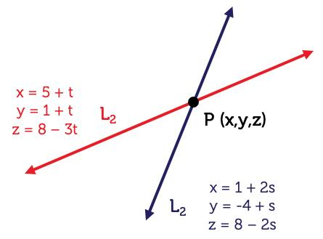
For example, two edges meeting at a corner of a solid may form intersecting lines when those edges are extended into complete straight lines.

Key Characteristics
# Source: AI Source: Provided by: [Data Path: Persons Table -> ID Column: 1, Name_En Column: Motasem Essam] -> From: [ChatGPT] on [7/25/2026]
- Common point: Intersecting lines share a point.
- Exactly one intersection: Two distinct straight lines can intersect at only one point.
- Coplanar: Intersecting lines lie in the same plane.
- Different directions: Their direction vectors are not parallel.
- Possible angles: They can intersect at a right angle or at another angle.
- Infinite extent: The complete lines extend infinitely in both directions.
- Three-dimensional setting: The lines may be positioned anywhere in space, provided they share a point.

Types of Intersecting Lines in Solid Geometry

1. Perpendicular Lines
# Source: AI Source: Provided by: [Data Path: Persons Table -> ID Column: 1, Name_En Column: Motasem Essam] -> From: [ChatGPT] on [7/25/2026]
Perpendicular lines intersect at a right angle of ${90}^{∘}$.
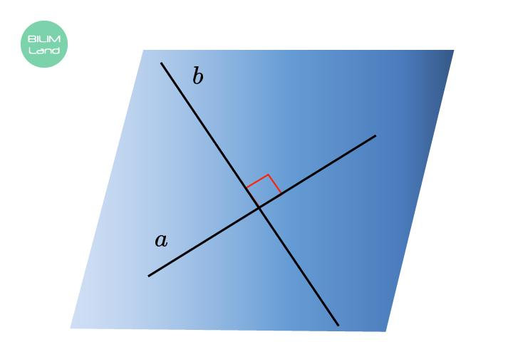
For direction vectors $u$ and $v$, perpendicularity is expressed as
$$u⋅v=0$$
provided both vectors are nonzero.
Examples:
- Two adjacent edges of a cube.
- Two perpendicular coordinate axes.
- Two lines crossing at a right angle on a plane of a solid.

2. Obliquely Intersecting Lines
# Source: AI Source: Provided by: [Data Path: Persons Table -> ID Column: 1, Name_En Column: Motasem Essam] -> From: [ChatGPT] on [7/25/2026]
Obliquely intersecting lines meet at an angle other than ${90}^{∘}$.
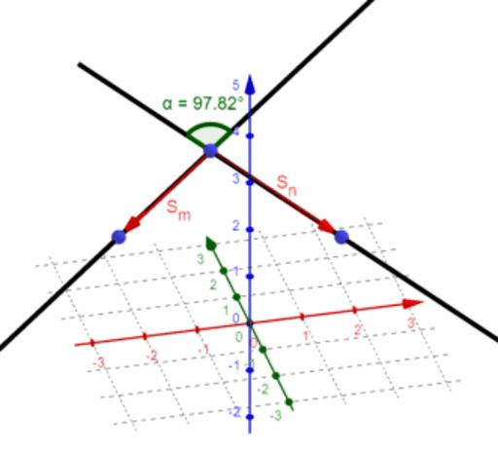
The angle between their direction vectors can be calculated using
$$\cos{θ}=\frac{\left|u⋅v\right|}{\left|u\right|\left|v\right|}$$
where $θ$ is the smaller angle between the lines, ranging from $0^{∘}$ to ${90}^{∘}$.
For example, two lines intersecting at ${45}^{∘}$ are obliquely intersecting lines.

3. Lines Intersecting at a Solid's Vertex
# Source: AI Source: Provided by: [Data Path: Persons Table -> ID Column: 1, Name_En Column: Motasem Essam] -> From: [ChatGPT] on [7/25/2026]
Two or more lines may intersect at a vertex of a polyhedron when the lines containing its edges are extended.
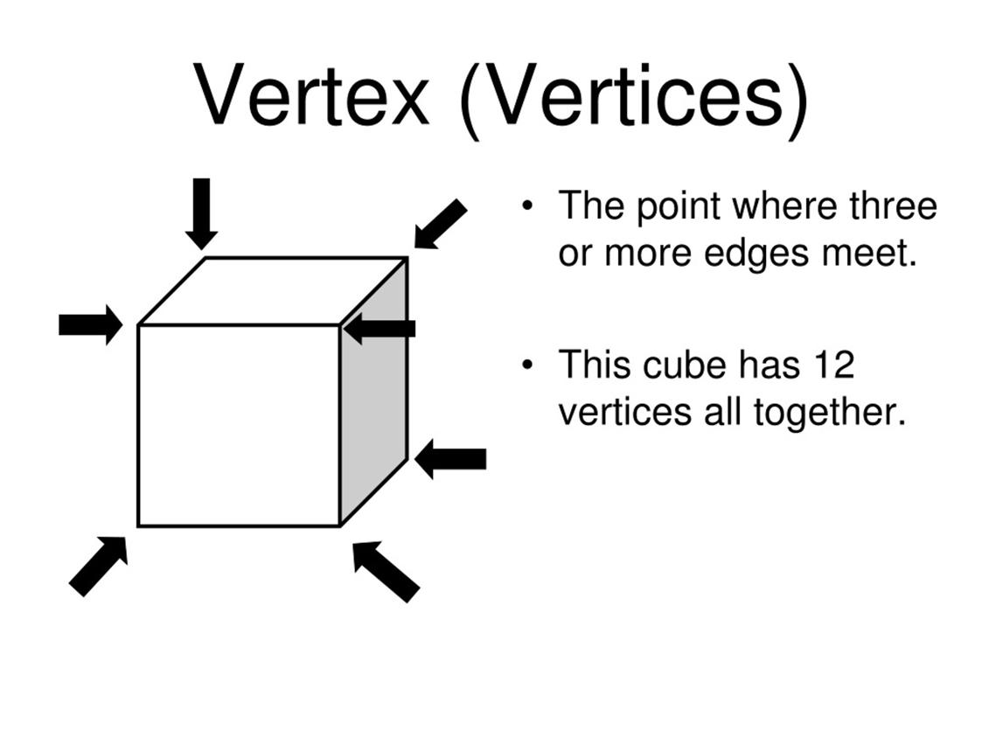
At a cube's vertex, three edge-containing lines meet. Each pair of these lines intersects at the same vertex.
Important: The three lines need not all lie in one plane. Each pair of intersecting lines lies in a plane, but three lines through the same point can have different spatial directions.

4. Lines Intersecting on a Face
# Source: AI Source: Provided by: [Data Path: Persons Table -> ID Column: 1, Name_En Column: Motasem Essam] -> From: [ChatGPT] on [7/25/2026]
Lines drawn or extended across the same face of a solid can intersect at a point on that face.
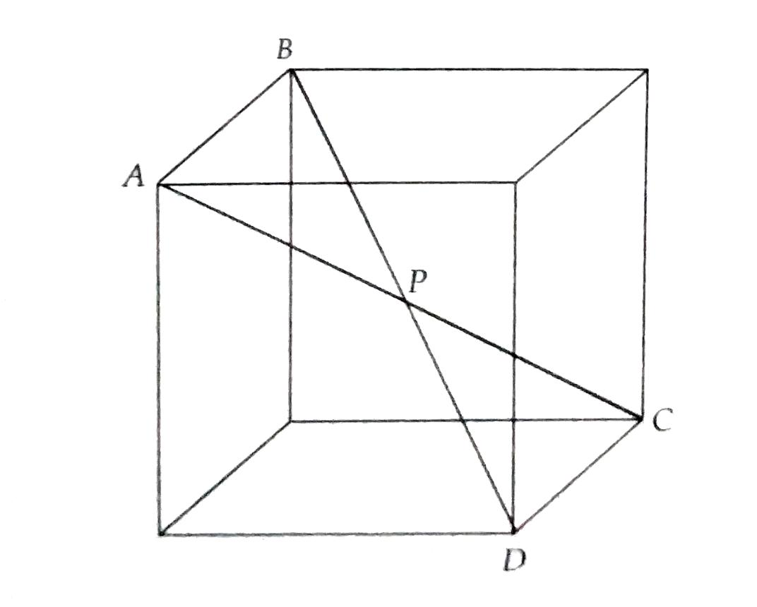
For example, the diagonals of a square face of a cube intersect at the center of that face.
If the square has side length $a$, its diagonals meet at their common midpoint.

5. Lines Intersecting at a Point in Space
# Source: AI Source: Provided by: [Data Path: Persons Table -> ID Column: 1, Name_En Column: Motasem Essam] -> From: [ChatGPT] on [7/25/2026]
Intersecting lines are not required to lie on the surface of a solid. They can meet at any point in three-dimensional space.
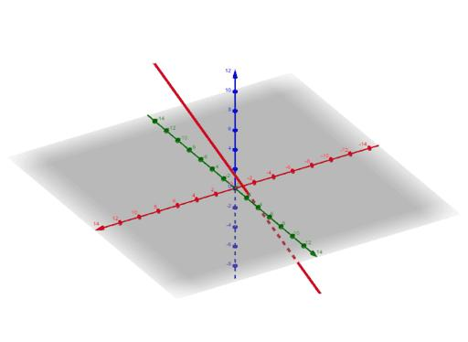
For example, consider two lines:
$$L_{1}:\left(x,y,z\right)=\left(1,0,2\right)+t\left(1,1,0\right)$$
$$L_{2}:\left(x,y,z\right)=\left(2,1,2\right)+s\left(0,1,1\right)$$
At $t=1$, the first line reaches $\left(2,1,2\right)$. At $s=0$, the second line is also at $\left(2,1,2\right)$.
Therefore, the lines intersect at
$$P=\left(2,1,2\right)$$

Mathematical Representation

1. Vector equations
# Source: AI Source: Provided by: [Data Path: Persons Table -> ID Column: 1, Name_En Column: Motasem Essam] -> From: [ChatGPT] on [7/25/2026]
Two lines can be represented by
$$L_{1}:r=a+tu$$
$$L_{2}:r=b+sv$$
where $t,s∈R$, and $u,v$ are nonzero direction vectors.
The lines intersect if there are real values of $t$ and $s$ such that
$$a+tu=b+sv$$
This produces three coordinate equations. A common solution identifies their intersection point.

2. Angle between intersecting lines
# Source: AI Source: Provided by: [Data Path: Persons Table -> ID Column: 1, Name_En Column: Motasem Essam] -> From: [ChatGPT] on [7/25/2026]
If the direction vectors are $u$ and $v$, the smaller angle between the lines is
$$θ=\cos^{-1}\left(\frac{\left|u⋅v\right|}{\left|u\right|\left|v\right|}\right)$$
The absolute value ensures that the result is the smaller angle between the two unoriented lines.

3. Intersection conditions
# Source: AI Source: Provided by: [Data Path: Persons Table -> ID Column: 1, Name_En Column: Motasem Essam] -> From: [ChatGPT] on [7/25/2026]
For two distinct lines in three-dimensional space:
- If their equations have a common point and their directions are not parallel, they intersect.
- If their direction vectors are proportional but the lines are distinct, they are parallel and do not intersect.
- If they are not parallel but have no common point, they are skew lines.
- If they share every point, they are coincident lines rather than distinct intersecting lines.

Worked Examples
# Source: AI Source: Provided by: [Data Path: Persons Table -> ID Column: 1, Name_En Column: Motasem Essam] -> From: [ChatGPT] on [7/25/2026]
Example 1: Finding the intersection point
Consider
$$L_{1}:\left(x,y,z\right)=\left(1,2,3\right)+t\left(1,0,0\right)$$
$$L_{2}:\left(x,y,z\right)=\left(4,2,3\right)+s\left(0,1,0\right)$$
For $L_{1}$, the coordinates are $\left(1+t,2,3\right)$.
For $L_{2}$, the coordinates are $\left(4,2+s,3\right)$.
Equating the coordinates gives
$$1+t=4⟹t=3$$
$$2=2+s⟹s=0$$
Both lines meet at
$$\boxed{P=\left(4,2,3\right)}$$
Example 2: Determining whether lines are perpendicular
Let the direction vectors be
$$u=\left(1,2,0\right), v=\left(2,-1,0\right)$$
Their dot product is
$$u⋅v=\left(1\right)\left(2\right)+\left(2\right)\left(-1\right)+\left(0\right)\left(0\right)=0$$
Therefore, if these lines intersect, they are perpendicular and form a ${90}^{∘}$ angle.
Example 3: Diagonals of a square face
A square face has vertices
$$A\left(0,0,0\right), B\left(4,0,0\right), C\left(4,4,0\right), D\left(0,4,0\right)$$
Its diagonals $AC$ and $BD$ intersect at the midpoint
$$P=\left(\frac{0+4}{2},\frac{0+4}{2},0\right)$$
Thus,
$$\boxed{P=\left(2,2,0\right)}$$
The diagonals intersect at the center of the square face.

Comparison with Related Types of Lines
# Source: AI Source: Provided by: [Data Path: Persons Table -> ID Column: 1, Name_En Column: Motasem Essam] -> From: [ChatGPT] on [7/25/2026]
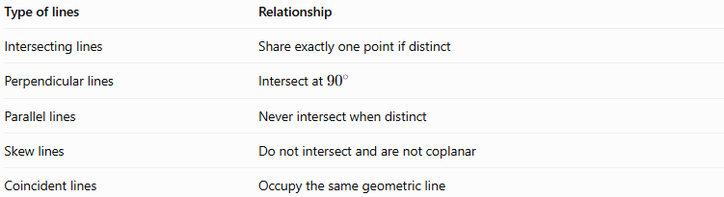
Type of lines | Relationship
Intersecting lines | Share exactly one point if distinct
Perpendicular lines | Intersect at ${90}^{∘}$
Parallel lines | Never intersect when distinct
Skew lines | Do not intersect and are not coplanar
Coincident lines | Occupy the same geometric line

Applications
# Source: AI Source: Provided by: [Data Path: Persons Table -> ID Column: 1, Name_En Column: Motasem Essam] -> From: [ChatGPT] on [7/25/2026]
- Solid geometry: Studying intersections between edges and diagonals.
- Architecture: Analyzing intersecting structural members.
- Engineering: Finding intersections between axes and straight components.
- Computer graphics: Calculating line intersections for rendering and collision detection.
- Coordinate geometry: Solving systems of equations in three dimensions.
- Technical drawing: Determining where projected or spatial lines meet.

Key Points
# Source: AI Source: Provided by: [Data Path: Persons Table -> ID Column: 1, Name_En Column: Motasem Essam] -> From: [ChatGPT] on [7/25/2026]
- Intersecting lines share a common point.
- Two distinct straight lines can intersect at only one point.
- Intersecting lines are always coplanar.
- Perpendicular lines are a special case of intersecting lines.
- The angle between intersecting lines can be calculated using their direction vectors.
- Lines through a common vertex need not all lie in the same plane.
- Skew lines are different from intersecting lines because they have no common point.

Conclusion
# Source: AI Source: Provided by: [Data Path: Persons Table -> ID Column: 1, Name_En Column: Motasem Essam] -> From: [ChatGPT] on [7/25/2026]
Intersecting lines in solid geometry are distinct straight lines that meet at a common point in three-dimensional space. Their intersection may occur at a solid's vertex, on a face, or elsewhere in space. Understanding their direction vectors, intersection equations, and angles helps distinguish intersecting lines from parallel, skew, perpendicular, and coincident lines.

